**CMP241 – Database Programming**

**Name: ____________________________________ Assume the following ERD for the questions below:**

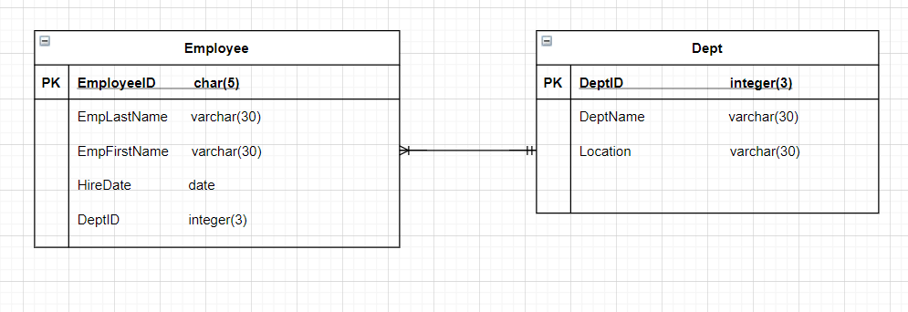

Assume these tables have been created with no keys or other constraints.

1. Using an ALTER TABLE statement, add the primary key constraint to the Employee table.
2. Using an ALTER TABLE statement, add the foreign key from Employee to Department on DeptID.
3. Using an ALTER TABLE statement, make the hire date column in the Employee table not null.
4. Using an ALTER TABLE statement, add a column to the Employee table called salary that is 9 digits total with 2 digits after the decimal place.
5. What is the difference between using CHAR and VARCHAR for a column that allows alphanumeric values?
6. Write a query to show all rows and columns in the Employee table.
7. Write a query to show the EmpLastName and EmpFirstName from the Employee table. Concatenate the columns together and change the columns heading.
8. Write a query to show the EmpLastName and the HireDate from the Employee table. Sort the data by HireDate in ascending order.
9. Write a query to show the DeptName for all Departments in the Toledo location.
10. Write a query to show the EmpLastName and DeptID for employees who have a salary greater than 50000.